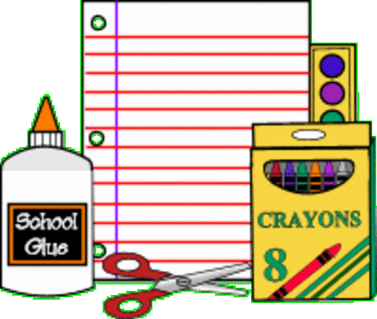
SUPPLY LIST for SECOND GRADE
CLYDE ELEMENTARY

- Four spiral bound notebooks
(red-yellow-blue-green) wide-ruled
- One 4-pack black EXPO Low-odor dry erase markers
- Crayola 24-count box of Crayons
- Crayola 12-count box of colored pencils
- Two 12-pack Ticonderoga #2 pencils
- One 4-pack Elmer glue sticks
- One plastic pencil box
- Three Post-it pads 3 inch

$2 for take home folder
$5 for Agenda Book

DO NOT send: Trapper Keepers, 3-ring binders, hand held pencil sharpeners
Wish List: Kleenex, Clorox Wipes, Lysol Spray

