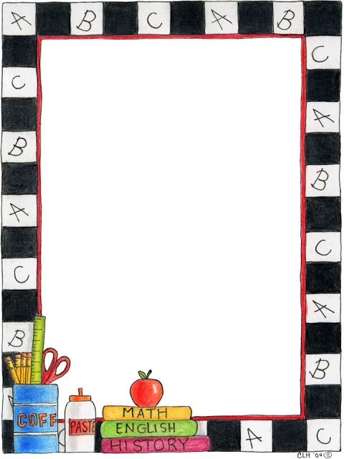
Mrs. Floyd’s Classroom Supply List
Elmer’s Liquid Glue
1 Pack of Glue Sticks
Tissues
1 Pack of Erasers (Either pencil top or pink erasers)
A snack to share with the class
1 pack of markers

Optional
1 watercolor paint set
1 container of Clorox wipes

