Clyde Elementary School Newsletter
April 2017
4182 Old Clyde Road, Clyde, NC 28721 (828) 627-2206
Dear Parents…
To keep our students, parents, and staff safe and also improve our morning car line drop-off, we would like to ask parents who walk their students inside the building to park in the upper parking lot. Once parked, please use the area marked as “crosswalk” on the picture to gain access to the school building. Thank you.
Upper Parking Lot
Crosswalk
ing a Love for Science  Science Expo  Tuesday April 4, 2017  Students will spend the day focusing on grade level science standards. Throughout the day, each grade level will test out their STEM creation and compete with other students! These STEM activities are designed to challenge students to “think outside the box” and find ways to experiment as scientist.  Here is a glimpse of activities:  Kindergarten: Egg towers  First: Strong houses that cannot be blown down by the "Big Bad Wolf"  Second: Musical instruments  Third: Marshmallow Catapults  Fourth: Bird Beaks  Fifth: Rollercoasters  II: All day STEM activities  Parents are welcome in the gymnasium  during your student’s scheduled time.  Time Grade Time Grade  8:15-9:10 Intensive Intervention 9:15-9:45 2nd grade  10:00-10:30 Kindergarten 11:00-11:30 5th grade  12:00-12:30 1st grade 12:45-1:15 3rd grade  1:30-2:00 4th grade  We are so excited to see our students transform into scientists! #cardinalympiad |  | Calling all Cardinals  against Cancer…  This year our staff has a Relay for Life team. We would love your help in our fundraising efforts to support the fight against cancer. Over the next few weeks we will be hosting several fundraising events in which you can help. Be on the lookout for memos coming home with your child advertising these events.  Egg Extravaganza: Week of April 3rd – 7th  Please collect any spare change you have…dig through the couch cushions, your car and empty your pockets! Each student will be sent home with an Easter Egg to fill with change on Monday, April 3. Please help us by sending those jingling eggs back to school by Friday, April 7th.  Name That Baby: Week of April 17th – 21st  Send your child with as many quarters as you can! A $0.25 donation allows your child to vote for the identity of a teacher. All Clyde Cardinal teachers will have baby photos posted. We would love to have your child vote. Each correct form will be placed into a drawing for a prize.
2nd graders are super excited about their field trip on Wednesday, April 5th to the Knoxville Zoo!
Reminder to parents to pick up their child up in car line at 4:00.

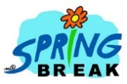
April 10th – 14th
We wish everyone a fun and safe !
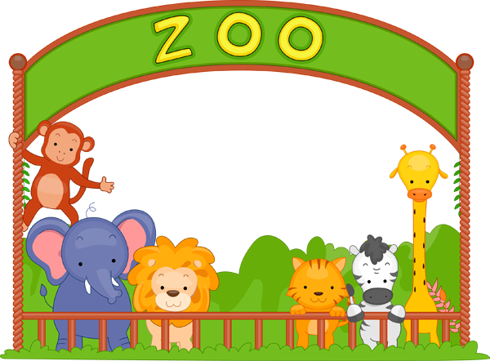
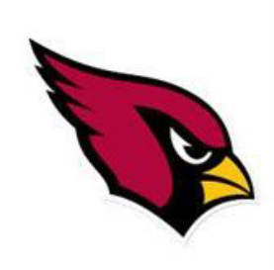

SPECIALS
Library- All grade levels are finishing the North Carolina Children’s Book Award nominees and voting. After Spring Break each grade will begin working on group research projects and creating products for their research.

PE- All grade levels are completing their fitness tests. This month we will be starting our Disc Golf unit!

Art- Students in all grades are wrapping up our unit on Asian Art and are traveling across the world to Africa for our next projects. Kindergarten and first grade will learn how to draw Giraffes and Elephants, second grade is learning about African Mud Huts, third grade is studying about hippopotamuses, and fourth grade is learning about the Maasai People of southern Kenya and northern Tanzania. Fifth grade will learn how to weave with yarn and create their own African Kente Cloth.

Guidance- On Wednesdays, K-2 students will focus on “blurting-out” and behaviors. Grades 3-5 will work on self-esteem and “being proud of you.” Monday, Tuesday, Thursday, and Friday K-2 classes will focus on career exploration. Grades 3-5 will research colleges and careers.

Music- Kindergarten is working on quarter and eighth note rhythms. 1st grade is continuing to put rhythms together. 2nd grade has finished learning about instruments. 3rd and 4th grades continue to enjoy themselves in “Mallet Madness” and are creating some wonderful music. 5th grade is working on a song for an upcoming performance and reading sixteenth note rhythms.

Computers- All students will be learning more about the new Google Chromebook tools with a specific focus on Google Docs.

Proctors needed for End-Of-Grade Testing.
What is a proctor? It is a person who monitors students during an examination.
You will receive training so you are fully prepared and know what to do during testing.
If you would be interested in helping with proctoring for the EOG tests, please let Ms. Reinhardt know!
Dates: May 31st & June 1st
*sreinhardt@haywood.k12.nc.us 627.2206
*Send a note to her!

5th Grade Announcements

Fifth graders will be traveling to Washington DC this month, April 19th-21st. We will be hard at work learning all about Monuments and Memorials in DC, as well as the branches of government.

Fifth Grade Parents of DC Travelers: Remember the MANDATORY meeting for you and your child on April 4th, at 5:00pm in the Media Center (Don't forget your Photo ID)!

Students have made a huge accomplishment by going through the DARE program here at school! We are going to hold a celebration to honor these DARE graduates on April 7th at 10:00 a.m. in the gym. Hope to see you there!

Students took a visit to a Middle School to get prepared for next year. They are filling out the sheets to choose the classes that they want to take. What can you do at home to help with this transition? Talk to your child about some of the expectations that the Middle School voiced to them. Set goals with your child about what they could be doing now, so that they are better prepared when they get to middle school next year.

Our students are going to have an exciting month learning all about Genetics in science! Students will be finding out traits that they inherited versus behaviors that they learned.
What to do at home? Take some time to look into your family history (freckles, height, dimples, etcetera).

Tips from Title One Literacy

A range of prior knowledge gives more meaning to reading.
Reading is one of the main ways students learn new things. And research shows that their ability to understand and relate to what they read is linked to what they already know—their prior knowledge.

When your child has some knowledge of a subject before he begins reading, he doesn’t have to figure out everything about the text just from what’s on the page. His prior knowledge gives him context to help him understand the new information. It may also keep him more engaged with what he’s reading.

To help your child gain knowledge he can draw on when he reads:
- Encourage him to read the newspaper. Reading a wide variety of articles will expose him to topics and themes—from history to geography to science—that he will be likely to encounter in his school reading.
- Broaden his world. Attend museum exhibits and cultural events together. Each bit of culture your child experiences may help him make a connection to something he will read in the future. Look online or in the newspaper for free or low-cost options.
- Share your experiences. Your child can benefit from your prior knowledge, too! Talk with him about places you have been, historic events you remember and jobs you have had.

